**EMPOWERING COMMUNITIES FOR SUSTAINABLE DEVELOPMENT**

**PROJECT REPORT**

1. **INTRODUCTION:**

In the face of global challenges such as climate change, environmental degradation, and social inequality, there is an urgent need for comprehensive and sustainable development solutions. The concept of sustainable development, as articulated in the United Nations' Sustainable Development Goals (SDGs), recognizes the interdependence of economic, social, and environmental factors. This project, "Empowering Communities for Sustainable Development," aims to contribute to the achievement of these goals by fostering community-led initiatives and promoting practices that ensure a harmonious balance between economic growth, social well-being, and environmental stewardship.

Sustainability have been determined in terms of no poverty, quality of education, life below water, reduced inequality, life on land, industry, infrastructure and innovation.

**II. LITERATURE SURVEY:**

**EXISTING PROBLEMS:**

* **Environmental Degradation:**

**Issue:** Uncontrolled deforestation, pollution, and unsustainable resource extraction contribute to environmental degradation, leading to the loss of biodiversity and disruption of ecosystems.

* **Social Inequality:**

**Issue:** Disparities in access to resources, education, and employment opportunities contribute to social inequality within communities.

* **Limited Economic Opportunities:**

Issue: Lack of economic opportunities, especially for vulnerable populations, hinders community development and perpetuates cycles of poverty.

* **Lack of Community Empowerment:**

Issue: Communities often lack the knowledge, skills, and resources needed to actively participate in decision-making processes and manage their own development.

* **Climate Change Vulnerability:**

Issue: Climate change poses a significant threat, leading to extreme weather events, changing precipitation patterns, and adverse impacts on agriculture and livelihoods.

* **Inadequate Waste Management:**

Issue: Improper waste disposal contributes to environmental pollution and poses health risks to communities.

* **Limited Access to Education and Skills Training:**

Issue: Insufficient access to education and skills training impedes individual and community development.

* **Weak Social Cohesion:**

Issue: Social divisions and lack of cohesion within communities hinder collaborative efforts for development.

Addressing these existing problems requires a holistic and integrated approach, where the community is actively involved in the decision-making process and implementation of solutions.

In the proposed approach apply the data analysis and visualization approaches like bar chart, pie chart and other representation. It provides more clarity to the decision maker.

**3. THEORITICAL ANALYSIS**

**1. Brundtland Commission and the Notion of Sustainable Development:**

The concept of sustainable development was popularized by the Brundtland Commission's report, "Our Common Future" (1987). It introduced the idea that development should meet the needs of the present without compromising the ability of future generations to meet their own needs.

This theory emphasizes the integration of economic, social, and environmental dimensions, highlighting the interconnectedness of global challenges and the necessity for a balanced approach to development.

**2. Ecological Modernization Theory:**

Ecological Modernization posits that environmental protection and economic development are not mutually exclusive. Instead, technological innovation and institutional change can lead to a more sustainable form of industrial society.

Analysis: This theory suggests that advancements in technology and changes in societal values can drive a shift towards sustainable practices, challenging the assumption that economic growth inherently leads to environmental degradation.

**3. Resilience Theory:**

Resilience theory focuses on the capacity of systems to absorb shocks, adapt to changing conditions, and maintain functionality. Applied to sustainable development, it emphasizes the importance of building resilient social, economic, and environmental systems.

Analysis: This theory recognizes the dynamic nature of ecosystems and human societies, advocating for strategies that enhance adaptability and reduce vulnerability in the face of uncertainties and disturbances.

**4. Social-Ecological Systems Framework:**

This framework integrates social and ecological systems, emphasizing their interdependence. It views sustainable development as the result of effective governance, adaptive management, and the promotion of social-ecological resilience.

Analysis: The Social-Ecological Systems Framework acknowledges that human well-being is intimately connected to the health of ecosystems, and effective governance is essential to balance competing interests and ensure sustainable resource use.

**5. Doughnut Economics:**

Doughnut Economics, proposed by Kate Raworth, presents a model where the goal of economic development is to ensure that human needs are met within the ecological boundaries of the planet.

This theory provides a visual representation of sustainable development, defining a "safe and just space for humanity." It encourages a regenerative and distributive economic model that operates within the ecological limits of the Earth.

**6. Triple Bottom Line (TBL) - People, Planet, Profit:**

TBL suggests that businesses and organizations should be assessed not only on their economic performance (profit) but also on their social and environmental impact (people and planet).

Analysis: This theory has been influential in corporate sustainability strategies, encouraging a broader perspective on success that incorporates social responsibility and environmental stewardship.

**7. Post-Development Theory:**

Post-Development Theory challenges traditional notions of development, questioning the Western-centric approach and emphasizing locally-driven, context-specific alternatives.

**Analysis:** This theory calls for a reevaluation of development paradigms, acknowledging diverse cultural perspectives and advocating for a more participatory and community-centered approach to sustainable development.

**IV. EXPERIMENTAL INVESTIGATION:**

Sustainable development data collection from Kaggle repository is made and and uploaded for in the IBM Cognos analytics for analysis.

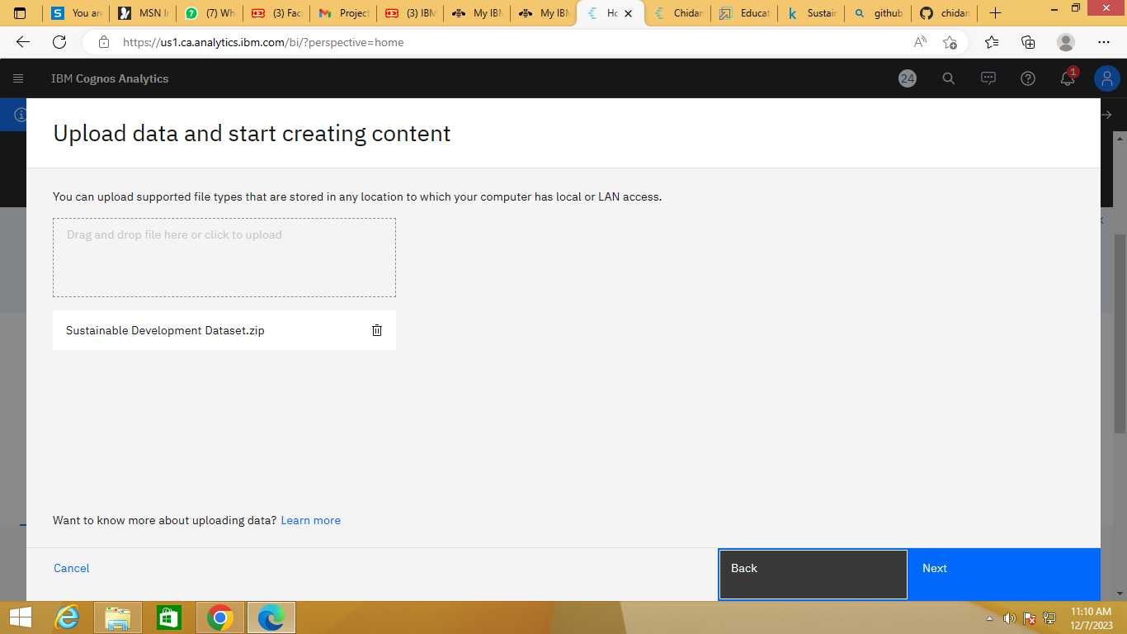

**CONNECT WITH IBM COGNOS**:

The list of features available in the dataset is displayed here.

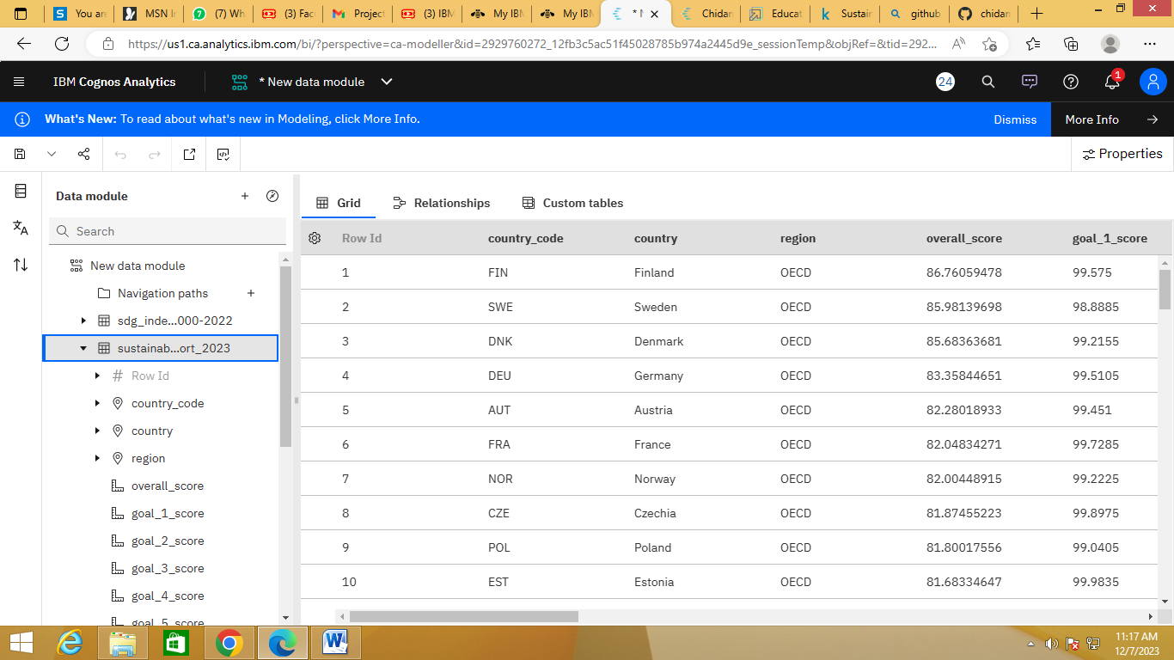

**Analysis on Overall Sustainability on No Poverty:**

The visualization has been made for the data which shows the overall sustainability towards no poverty with respect to country.

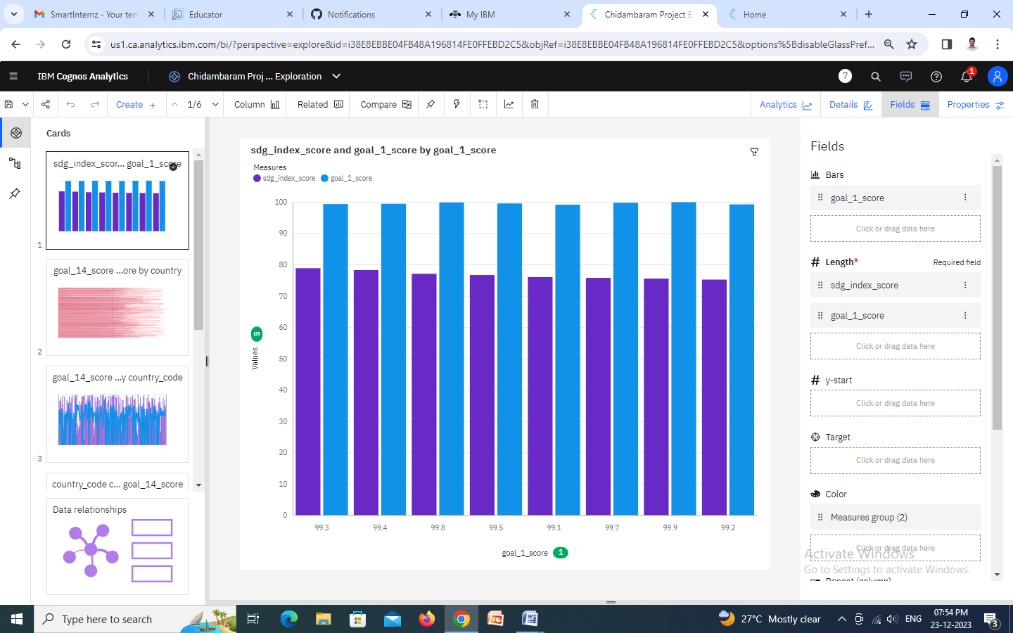

### Analysis Overall Sustainability on Quality Education:

### The visualization has been made for the data which shows the sustainable development with respect to quality education provide in various geographic places. From that educated and un-educated people can be determined.

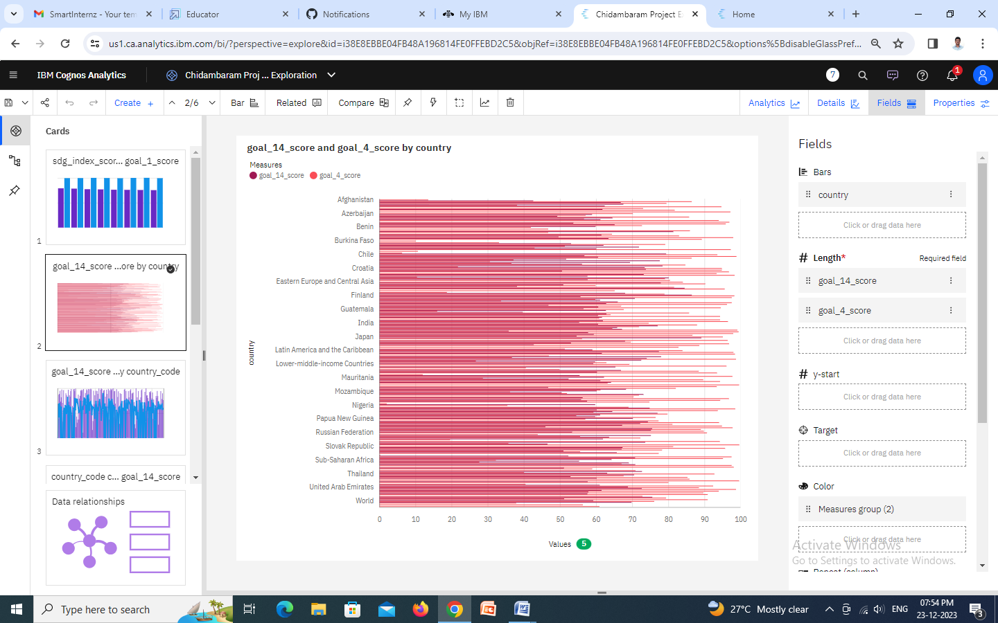

### Analysis on Overall Sustainability Life below Water:

### The visualization has been made for the data which shows the overall sustainability towards life below water.

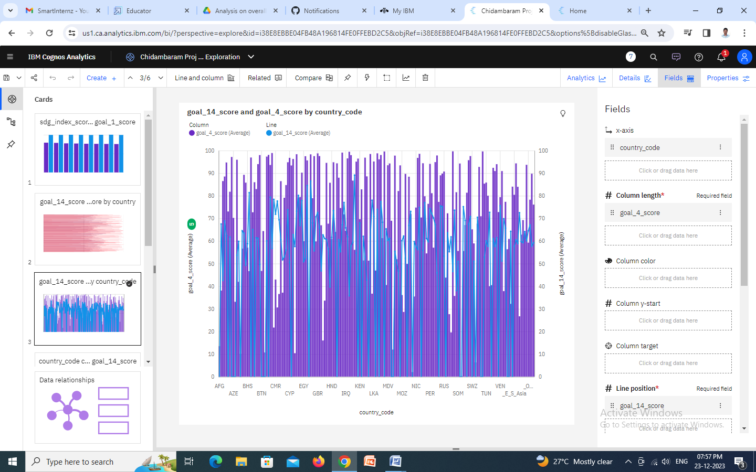

### Analysis on Overall Sustainability Partnerships for the Goals:

### The visualization has been made for the data which shows the overall sustainability towards partnership for the goals.

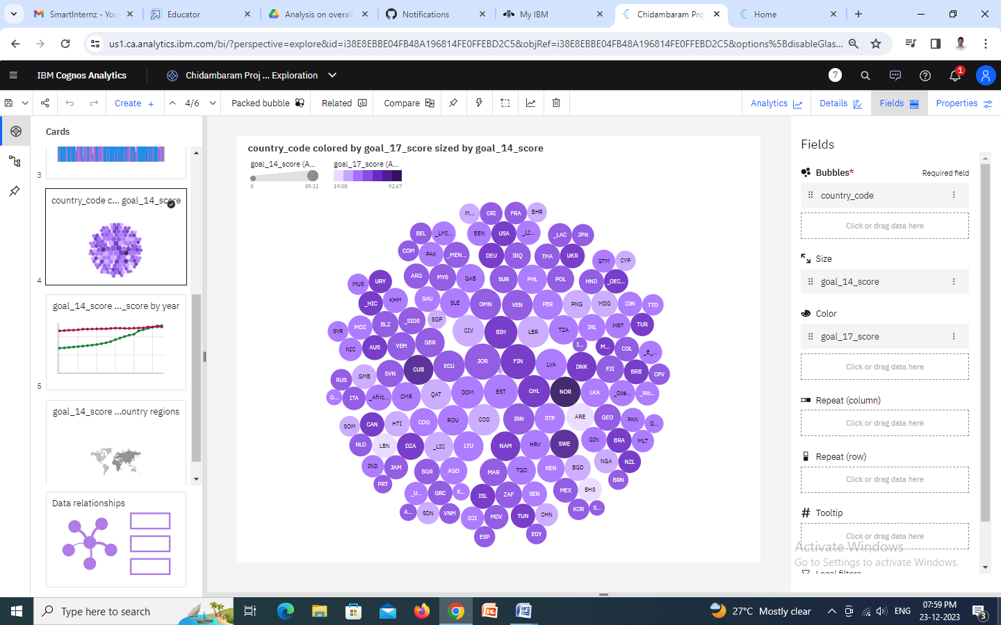

### Analysis on Overall Sustainability Reduced Inequalities:

### The visualization has been made for the data which shows the overall sustainability in terms of reduced inequalities in different region.

### 

### Analysis on Overall Sustainability Industry, Innovation and Infrastructure:

### The visualization has been made for the data which shows the overall sustainability happened in the industry development, innovation and infrastructure facilities available.

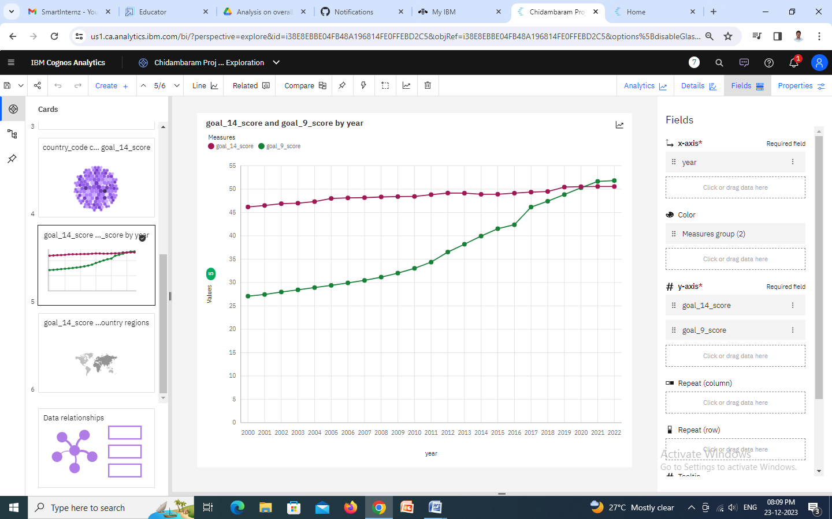

### Analysis on Overall Sustainability Life on Land:

### The visualization has been made for the data which shows the overall sustainability towards life on land.

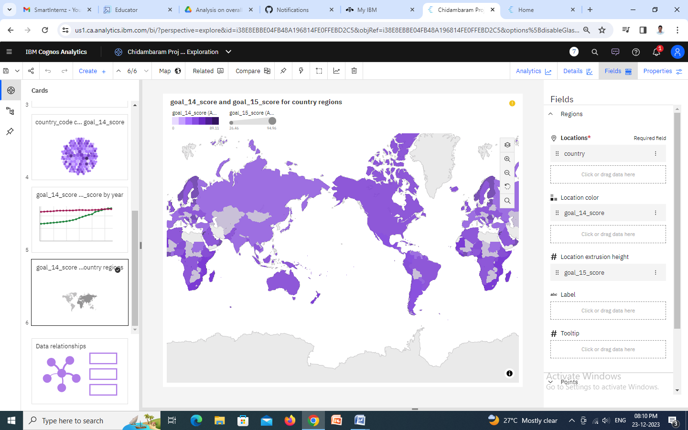

**V. Flow Diagram:**

**Data Analytics Platform**

**Data Collection and Integration**

**Input Data set**

(Sustainable development)

**Descriptive Data Analytics**

**Data Preprocessing** (Data Cleaning)

**Predictive Data Analytics**

**Data Visualization using Tools**

**Prescriptive Data Analytics**

**VI. APPLICATIONS:**

Visualizing sustainable development with data analytics offers numerous applications across various domains. Here are some key applications:

* **Environmental Monitoring:**

**Use Case:** Tracking air and water quality, deforestation rates, and wildlife population changes.

**Benefits:** Early detection of environmental issues, informed decision-making for conservation efforts, and assessing the effectiveness of environmental policies.

* **Energy Consumption Optimization:**

**Use Case:** Analyzing energy consumption patterns in urban areas and industries.

**Benefits:** Identifying opportunities for energy efficiency, optimizing resource allocation, and reducing carbon footprint.

* **Smart Cities and Urban Planning:**

**Use Case:** Analyzing urban development data, traffic patterns, and public transportation usage.

**Benefits:** Optimizing city infrastructure, improving traffic flow, and enhancing public services to create more sustainable and livable cities**.**

* **Water Resource Management:**

**Use Case:** Monitoring water usage, analyzing drought patterns, and assessing water quality.

**Benefits:** Efficient allocation of water resources, early detection of water scarcity and implementing sustainable water management practices.

* **Renewable Energy Integration:**

**Use Case:** Analyzing data related to renewable energy production, storage, and consumption.

**Benefits:** Optimizing the integration of renewable energy sources into the grid, reducing reliance on fossil fuels, and promoting sustainable energy practices.

* **Supply Chain Sustainability:**

**Use Case:** Tracking and analyzing the environmental impact of supply chains**.**

**Benefits:** Identifying areas for improvement, reducing waste, and ensuring sustainable sourcing and manufacturing practices.

* **Social Impact Assessment:**

**Use Case:** Analyzing social and economic indicators to assess the impact of development projects on communities.

**Benefits:** Ensuring inclusive and equitable development, addressing social inequalities, and measuring the success of poverty alleviation programs.

* **Biodiversity Conservation:**

**Use Case:** Monitoring changes in biodiversity through data on flora and fauna.

**Benefits:** Identifying endangered species, understanding ecosystem health, and guiding conservation efforts.

* **Disaster Preparedness and Response:**

**Use Case:** Analyzing historical data to predict and respond to natural disasters.

**Benefits:** Improving early warning systems, optimizing emergency response plans, and minimizing the impact of disasters on communities.

* **Corporate Sustainability Reporting:**

**Use Case:** Analyzing corporate data related to environmental, social, and governance (ESG) factors.

**Benefits:** Enhancing transparency, meeting regulatory requirements, and promoting responsible business practices.

* **Healthcare Planning and Infrastructure:**

**Use Case:** Analyzing health data to plan and optimize healthcare infrastructure.

**Benefits:** Improving access to healthcare, identifying disease patterns, and enhancing public health initiatives.

* **Educational Planning and Access:**

**Use Case:** Analyzing data on education access, dropout rates, and learning outcomes.

**Benefits:** Improving education policies, addressing inequalities, and ensuring sustainable development through education.

These applications demonstrate the versatility of visualizing sustainable development with data analytics, providing valuable insights for informed decision-making and promoting a holistic approach to addressing environmental, social, and economic challenges.

**Conclusion:**

Visualizing sustainable development through data analytics plays a crucial role in addressing complex challenges across environmental, social, and economic domains. The applications of data analytics in the context of sustainable development are diverse and impactful. By leveraging data-driven insights, decision-makers can make informed choices that lead to more effective and sustainable solutions.